**The Tragedy of Flight: A Comprehensive crash analysis**

**Submitted by**

**VARSHA M : 20203251522203**

**RAJESH R : 20203251522201**

**SURESH S : 20203251522202**

**INTRODUCTION**

An airplane crash analysis is a detailed investigation into the causes of an aviation accident. The goal of an airplane crash analysis is to identify any factors that contributed to the accident, with the ultimate goal of improving safety and preventing future accidents. The process of conducting an airplane crash analysis typically involves the collection and analysis of a wide range of data, including information about the aircraft and its systems, the operators, and any other relevant factors. This data is typically collected from Kaggle. Once the data has been collected, it is analysed through tableau, to identify any potential causes of the accident. The results of an airplane crash analysis are typically published in a report, which may include recommendations for improving safety and preventing similar accidents in the future. These recommendations may be implemented by the relevant authorities or industry organizations.

**Technical Architecture**:

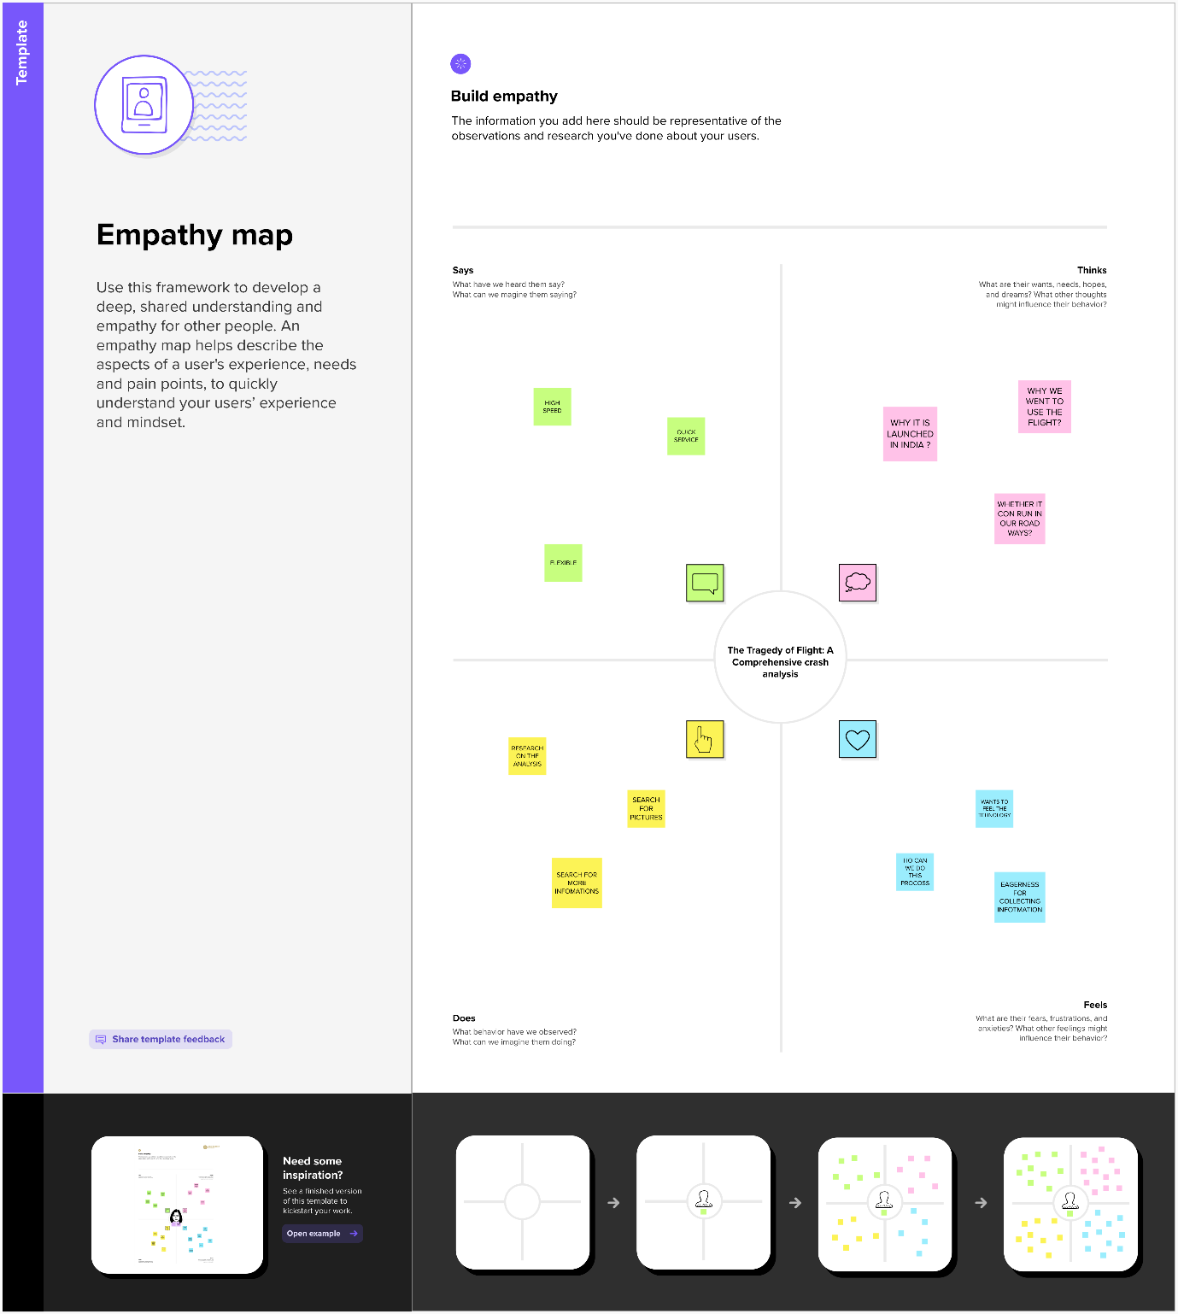



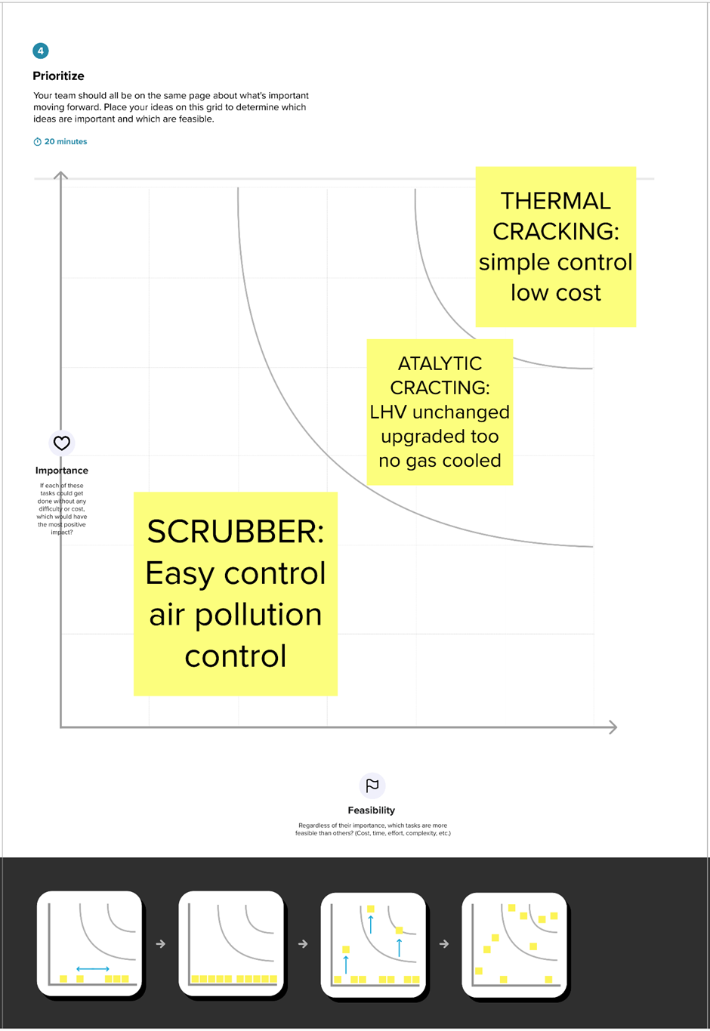

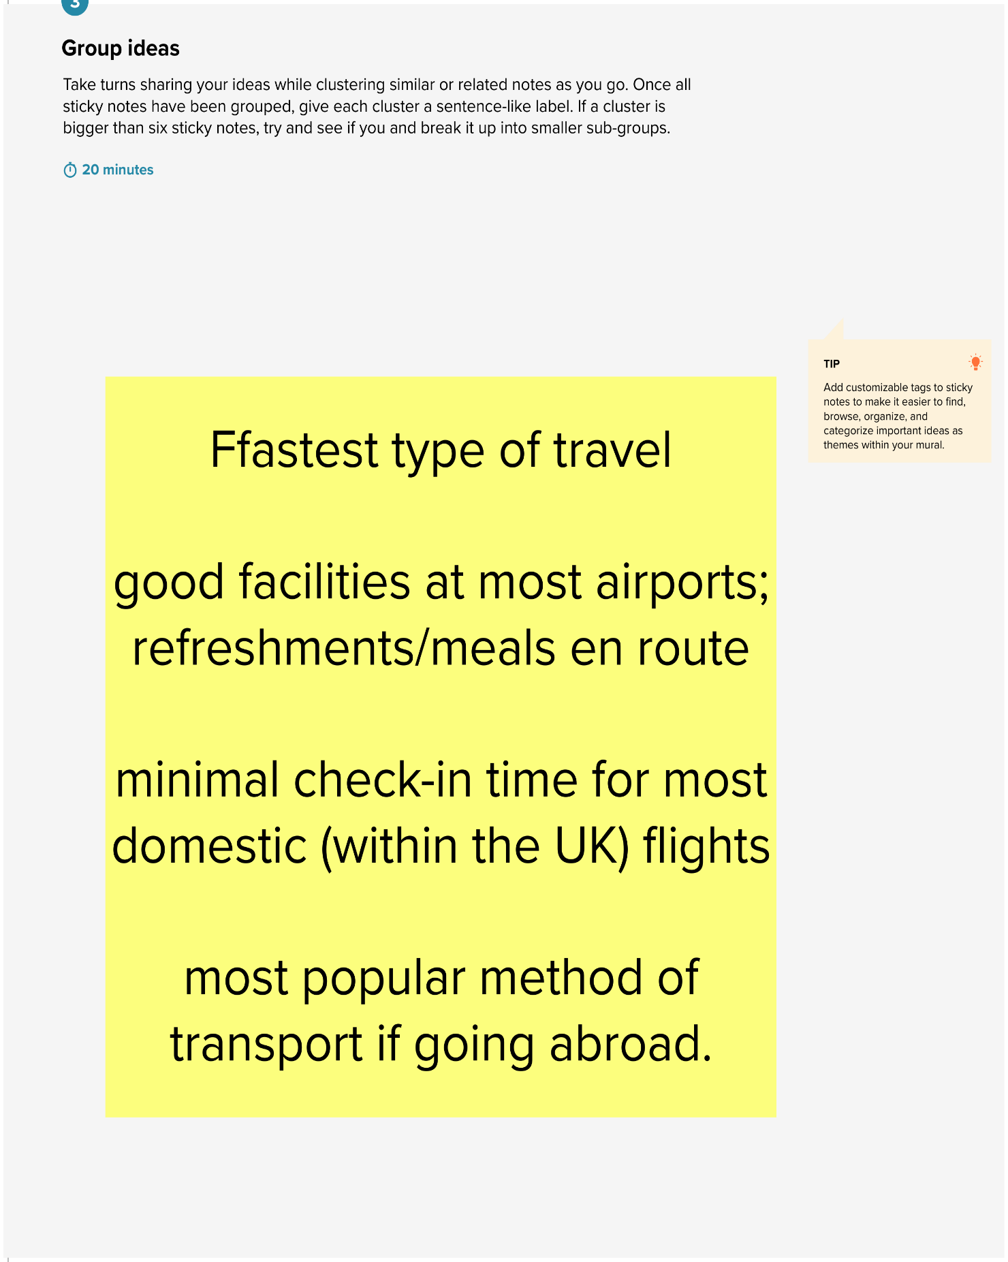

**RESULT**

**DASHBOARD**

A dashboard is a collection of several views, letting you compare a variety of data simultaneously.

|  |
| --- |
| **The Tragedy of Flight: A Comprehensive crash analysis** |

|  |
| --- |
|  |

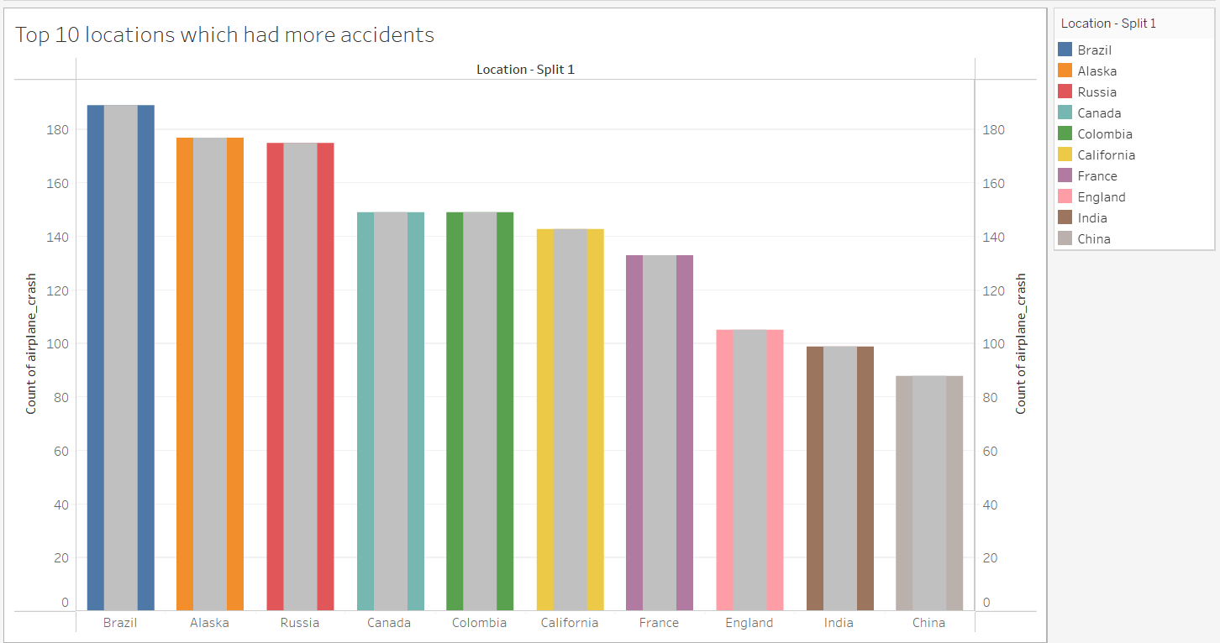

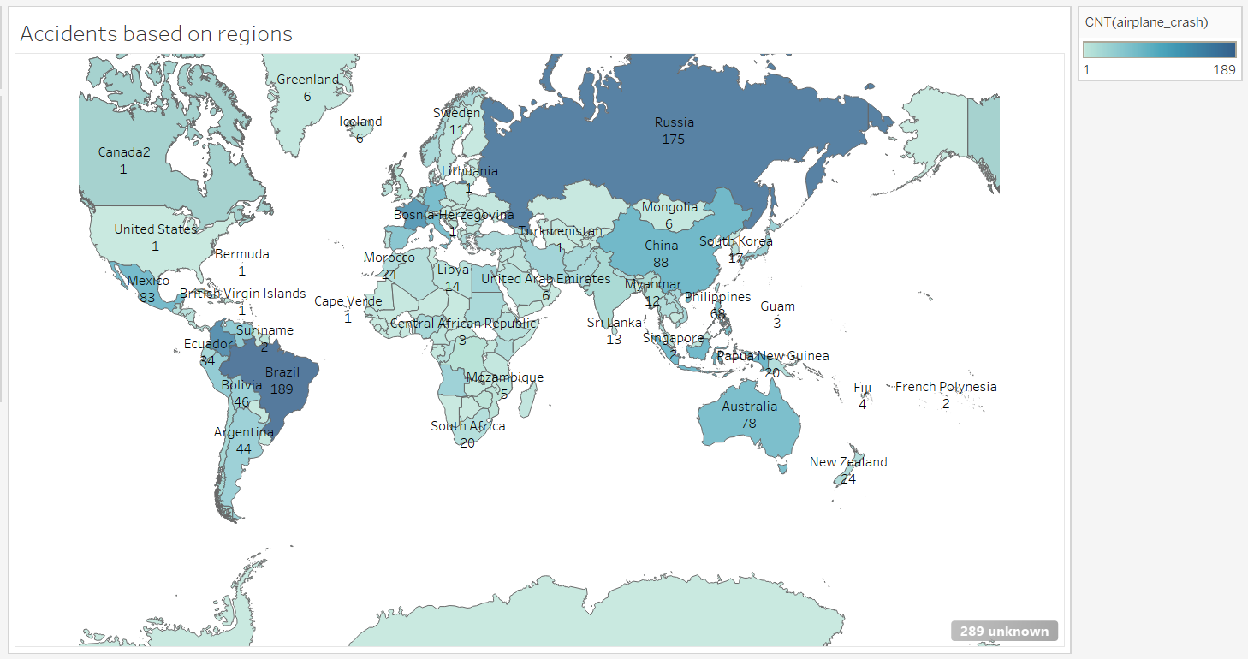

**STORY:**

A story is a sheet, so the methods you use to create, name, and manage worksheets and dashboards also apply to stories. At the same time, a story is also a collection of sheets, arranged in a sequence. Each individual sheet in a story is called a story point.

**Story on The Tragedy of Flight: A Comprehensive crash analysis**

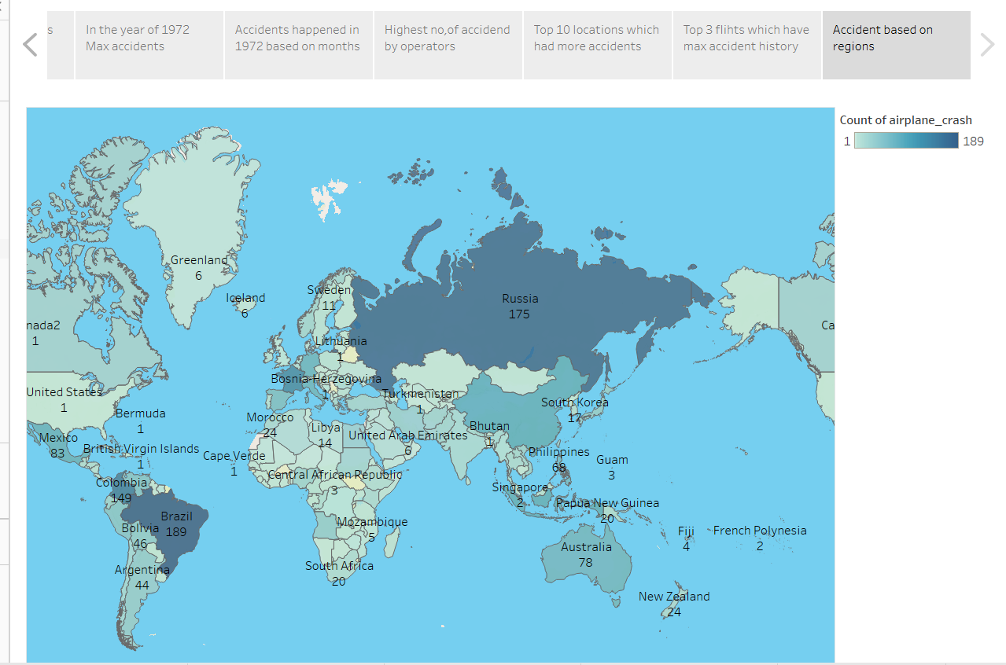

**ADVANTAGES AND DISADVANTAGES**

**Advantages:**

1. planes have multiple engines and backup systems, and even emergency systems such as engine fire detection and supression.

2. planes are less susceptible to weather, fly over most weather, and fly well above any terrain.

3. planes fly by instrument flight rules, they can fly through the clouds under air traffic control radar surveillance.

4. planes only fly on established instrument flight routes.

**Disadvantages:**

1 .The most common reason for an airplane crash is bad weather conditions. Heavy rains, thunderstorms, crosswinds, etc., can make flying very difficult for the pilot. In such conditions, it is quite easy for the plane to lose control and crash. Sudden changes in the weather can also create problems.

2. Causes of Plane Crashes Pilots have to be very careful while flying in bad weather conditions. They must always keep an eye on the radar and be in constant communication with the air traffic control tower.

3. The problem with nature is that it is unpredictable. So, even if the pilot is.

**APPLICATIONS**

fter investigating the wreckage NTSB dismissed any possibility of any terrorist activ1. The invention of the Traffic Collision Avoidance System

TCAS is a system in which both the aircraft in air communicate with each other with the help of transponders fitted on both of them, then a computer system on both of them calculates the altitude that the aircraft should gain to avoid collision with other aircraft. To know more about TCAS click here andUntil the late 90’s only the Air Traffic Control (ATC) was responsible for regulating the air traffic up in the sky and avoid collisions between different aircrafts but in 1956, a TWA plane crashed into a United Airlines flight above the Grand Canyon. The incident was the first of many that illustrated the need for increased communication between planes. After that FAA was formulated and TCAS system was made mandatory for all the airlines to get fixed on their aircraft which has almost eliminated the cases of air midair collisions of two aircraft. Though a major drawback of TCAS system came forward by another air crash which happened between a commercial flight and cargo aircraft in which both the aircraft were carrying a functional TCAS system on board but the protocol being followed by the pilot in commercial flight was to keep the decision of TCAS above ATC and that by the pilot in cargo flight was to keep the decision of ATC above TCAS, both the pilots followed the decisions as per the protocols and in the end both of the aircrafts found themselves at the same altitude and crashed into each other.

2. Weather Sensing Radars

You will fell turbulence in every other flight flying in airfield across the globe, not always the pilot is the reason behind those shaky and noisy flights. It is the weather outside which brings in too much turbulence and uneasy flights. Sometimes this weather turns so hostile that it may result in major catastrophic air accidents. Delta Airlines Flight 191, which crashed in 1985 while approaching Dallas-Fort Worth International Airport in a thunderstorm in an example of weather being the reason behind the air crash. Rain is another thing but if a pilot comes in a thunderstorm or a wind current it can pick and throw the aircraft on the ground like nothing. The weather sensor is not a very complicated device but is indeed a very important one, it senses the weather conditions near the aircraft and gives the information about those conditions in the cockpit so that the pilot can decide his flying direction accordingly. The major condition that the weather sensors detect are the wind shear, a wind shear is a condition in which the speed of air varies along the horizontal and vertical direction. Getting into a wind shear is very easy and you may never come out of wind shear until you are very lucky.

3. Leg Space between seats

Though you may feel a bit cramped while traveling in the economy class flights but still they are under set standards by the international governing bodies. Due to increasing fuel prices, airlines started directing the airframe manufacturers to have a maximum number of seats in an aircraft which gave rise to aircraft having lesser leg room between the seats. Then came forward a tragedy in which British Airtours 737 caught fire before takeoff at Manchester International Airport in 1985 and passengers were unable to eject from the aircraft due to lesser space between seats which created a panic and most of them burnt to death.

The incident gave rise to research work around the globe and Canfield Institute came up with a research which proved that through the emergency doors were open but there was no space between seats as well as between seats and emergency doors for people to eject. This gave rise to proper and stringent standards about the leg room between seats in an aircraft.

4. Electric spark elimination

Everybody was stunned after hearing about the TWA flight 800 which exploded midair, A Boeing 747 carrying 230 people from JFK to Paris turned into a huge explosion killing all the people on board. After investigating the wreckage NTSB dismissed any possibility of any terrorist activity.

**CONCLUSIONS**

He cause of this accident is the combination of several factors, ambiguously written procedures, inadequate training, unexpected operational situations or individual judg ments. Situational awareness, environmental and crew coordination factors, as well as shortcomings in pilot technical knowledge, skills and experience, also can cause acci- dents. Other mistakes might be the result of improper airspace design or crew coordi nation. As an initial event, the clear ice formed on the upper surface of the wings was not detected and de-iced well. The company instruction, procedures and even the equipment were not sufficient to remove the clear ice from the wing surface. Hence during the take- off the clear ice was broken off the wings and ingested by the engines and caused damage the engine fan stages, which led to engine surges and failure. The pilot had no sufficient knowledge and training to identify the problem and taking the necessary action. Further- more, there was no knowledge for applying Automatic Thrust Restoration system (ATR) within the company (SAS). Therefore it was activated and increased the engine power without the pilot knowledge. Another contributing cause was poor emergency landing responses in terms of speed and flap position for approach and landing. Finally, it may be concluded that unsafe pre-conditions which had been created by SAS organization in terms of training, instruction, operational procedures etc. were blamed for pilot and technicians errors and mistakes which led to the crash.

**FUTURE SCOPE**

Aviation accidents continue to horrify till this day, yet safety has been the highest priority for the aviation industry over the past 100 years. Technology, training and risk management have together resulted in laudable improvements.

Despite the recent tragic loss activity, flying is often said to be the safest form of transport, and this is at least true in terms of fatalities per distance travelled. According to the Civil Aviation Authority, the fatality rate per billion kilometres travelled by plane is 0.003 compared to 0.27 by rail and 2.57 by car.

A recent report suggested that hydrogen-powered planes could enter the market as soon as 2035, and those planes could carry hundreds more passengers per flight than traditional planes, with a cleaner energy source.

Thus , the project is useful for the researchers to analyse the tragedy of flight crash and aviation safety.